Imperial College Prosthetics Society: FDM Printing
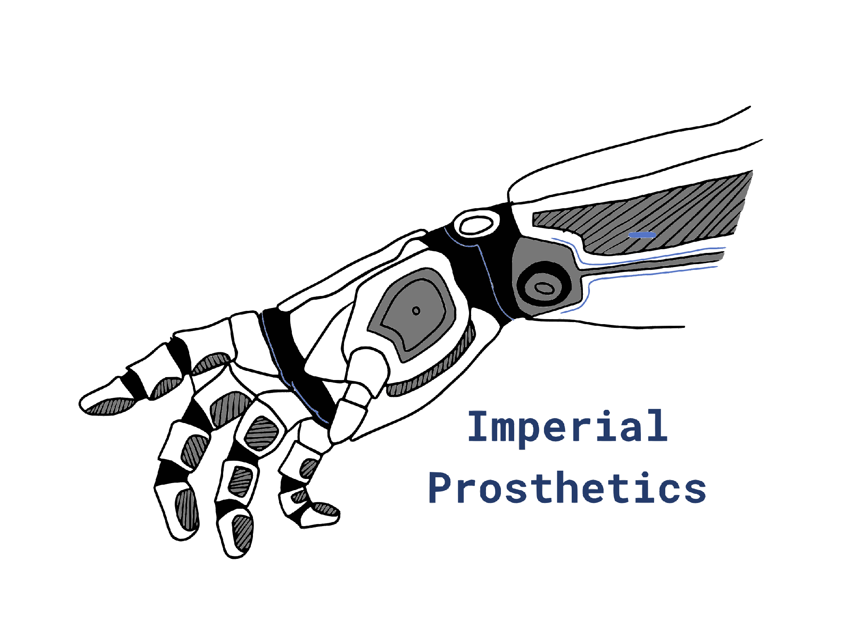

Version | Date | Description | Authors
1.0 | 19/04/26 | First Draft | Prithvi Philip
1.1 | 18/05/26 | Details of how to take off a print and post process | Prithvi Philip

The aim of this document is to enable future members to get familiar with:
- How FDM printing works
- Common slicer settings
- Preventing print failures
- Design for 3D printing, saving time and material
- Other slicer settings and features

For any queries: contact Prithvi (pp1123@ic.ac.uk)
Please @prithvi.philip@gmail.com in comments or dm me if you have any queries so I can improve this document

Contents
Prelude 2
How does FDM printing work? 3
Introduction to the Slicer and some Common Settings 5
Preparing the file 5
BambuStudio Slicer 5
Printing 10
Removing & Post Processing 11
Materials 11
Ensuring Prints Succeed 12
Design for Manufacture in 3D Printing 12
Advanced 3D Printing & Settings 18
Printing Failures? 21

Prelude

If you see your or someone else’s print fail – pause or stop the print and speak to the relevant technician/member of staff
If you see a printer doing something that it should NOT be doing, stop the print if you feel safe doing so and immediately speak the relevant member of staff. Reasons to speak to staff include:
- A blob collecting on the printer head/nozzle
- The printer is scratching the bed
- Parts seems to be coming loose
- Unusual Sounds (Note that at the start of a Bambu print, the printer will make a ‘brrrrr’ sound as part of vibration calibration)

Note:
- You will notice that there are a lot of links on this document. That is because, like CAD and many other things, it is best to learn by searching how to do things – but also thinking critically.
- There are various forms of additive manufacturing. We will focus on Fused Deposition Modelling (FDM) since it is the most commonly available and great for rapid prototyping but it has its drawbacks. SLA and SLS printing are also somewhat common (Formlabs – comparison of Additive Manufacturing ). There are even more types of printing such as metal 3D printing and more!
- The Printer/Slicer software we will focus on is Bambu Labs / Bambu Studio because Bambu printers are more common at Imperial College London. Bambu slicers/printers are less customisable but more robust. Alternative printers includer Prusa and alternative slicers include PrusaSlicer and OrcaSlicer
- Panning and Rotating about the screen is not discussed as it is similar to CAD UI. This varies between slicer type.

How does FDM printing work?

- It is worth researching yourself but a brief way to describe it is a nozzle extrudes melted plastic which sticks to the print bed and subsequently prints layer by layer
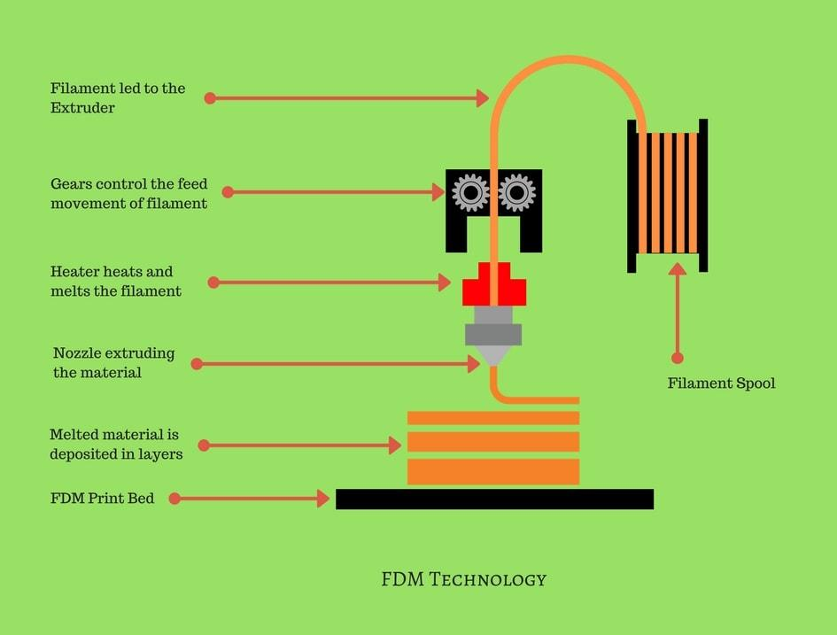
3dspro - Source
- It would take longer for a printer to have to print parts in solid, so they use infill. This gives the part strength but also saves significant printing time.
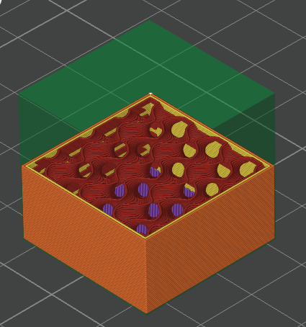
- How do you tell the printer to do this?
  - Using a Slicer – a software which converts your model into machine code (G-code)
  - You upload a model into the slicer
  - You adjust the print settings and the model
  - You “Slice” the model. This converts your model into layers (layer lines), which the printer will have to extrude material on each time
  - You export the G-code file – a file with a set of functions which tells the printer what X,Y,Z positions it should be, temperatures and controls material extrusion and in what order it should be doing those functions.

Introduction to the Slicer and some Common Settings

Preparing the file
- The most common files to import are .stl files and .step files.
- .stl files take less storage but may have a not as good resolution in curved surfaces
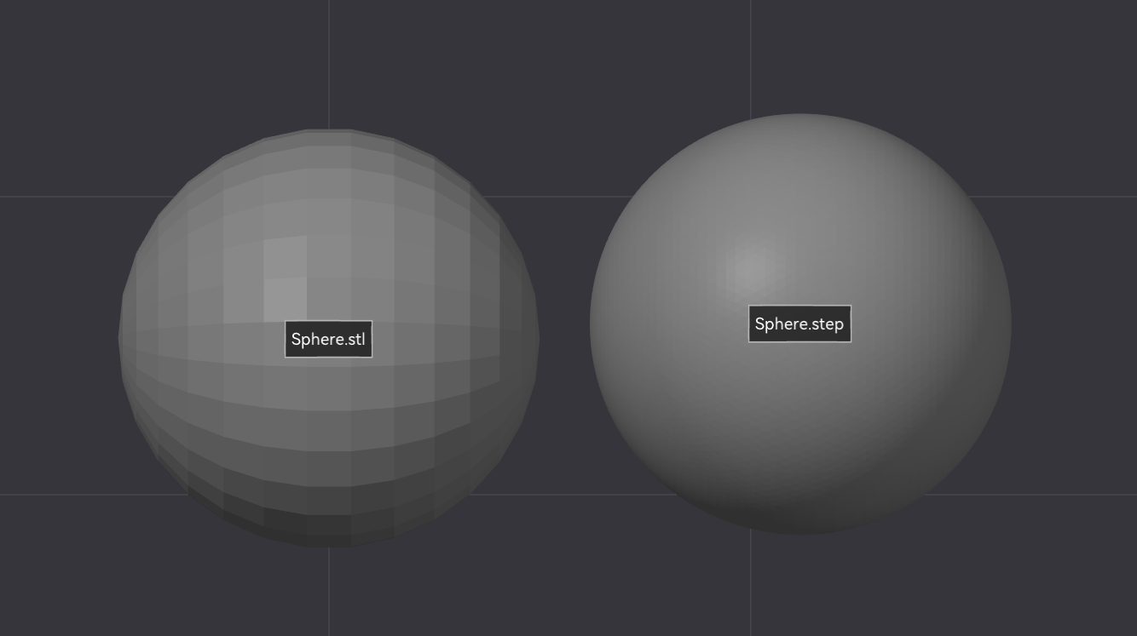
Bambu - Step vs Stl
- To export a file from a CAD software
  - SOLIDWORKS: File > Save As > Select STL/STEP file type
  - Fusion360: File > Export > Select STL/STEP file type
- Files can be imported from Printables and Thingiverse

BambuStudio Slicer
- Download the BambuStudio Slicer
- If prompted to select printers types, filament type: choose based on what is available to you. A generic choice is fine for now but will have to be updated for printer/filament you choose.
- It is most likely that the Nozzle Diameter of the extruder is 0.4mm and it is important that you set the correct value in the Slicer or prints will fails and you may damage the machine. A common setup is shown in the image below (Note: printer selection is arbitrary):
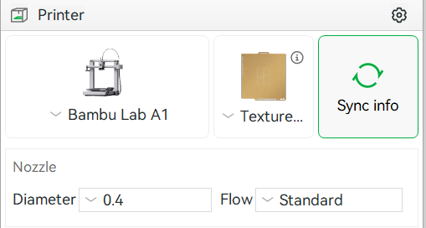
- Key features on the BambuSlicer have been labelled in the image below. Note for the purpose of this document, the top section will be known as the Toolbar and the section on the left as the Sidebar:
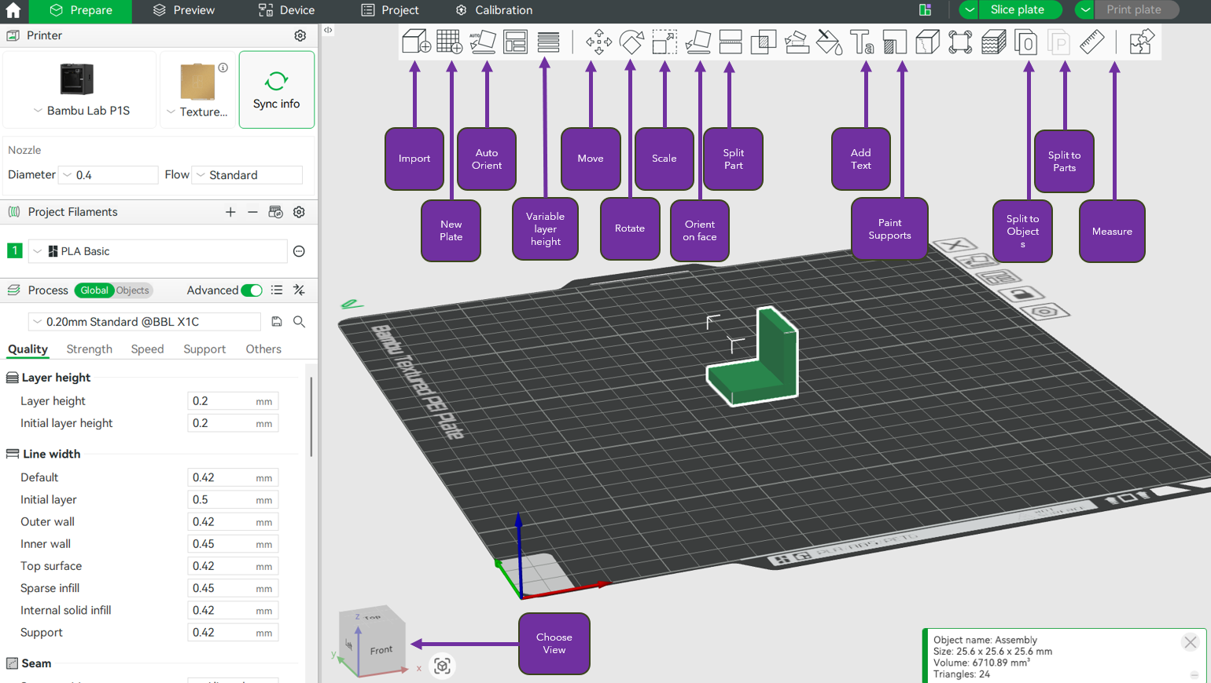
Using the toolbar:
- The Import tool can be used to import a file into the slicer.
- New Plate adds an additional print bed which can be used for an alternate print.
- Clicking Auto Orient after selecting a part will choose what the software thinks the orientation that minimises the required support is. This is NOT necessarily the best orientation for your needs.
- Variable Layer Height enables altering the layer height, allowing for a better print quality and a faster speed for parts with high curvature.
- Move, Rotate & Scale are intuitive
  - In Rotate, Hovering over the inner spokes snaps the angles to multiples of 45°
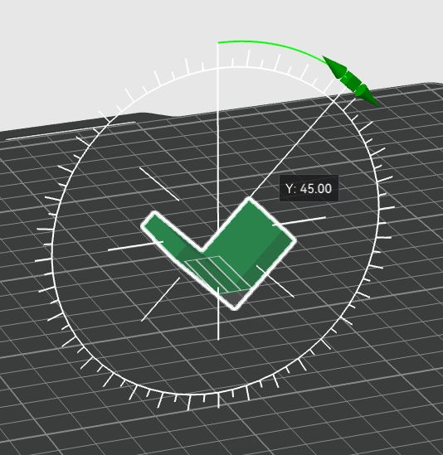
  - In Scale, switch off Uniform Scale to adjust a specific dimension (x, y, z)
- Orient on Face (Lay on Face), allows you to choose which face of the model sits on the base
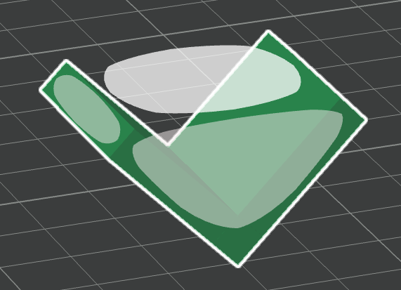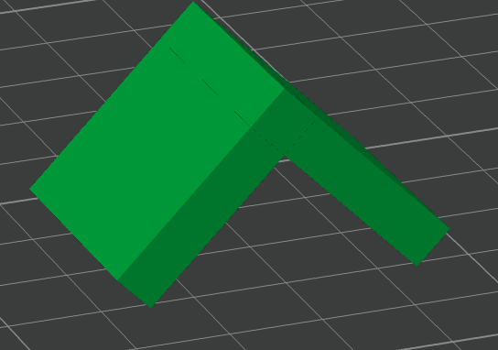
- Split Part is intuitive.
- Add Text enables you to emboss or deboss text onto a face
- Paint on Supports enables you to specify where supports should/should not be placed
- Split to Objects/Parts is used when you would like to split multi-body parts for the purposes of print). There is an equivalent Merge Parts if you select multiple parts and right-click.
  - Split to Objects creates an individual object for each shell and places each newly created object on the print bed (BambuLab Wiki).
  - Split to Parts keeps a single object and creates multiple parts for this object. After splitting, each part stays in its original position and will not be moved to the hot bed like an object (BambuLab Wiki).
- Measure can be used to measure distances and angles between geometry

- Saving the file will prompt to save as a .3mf file which is standard for printing files

Using the sidebar
- Filaments
  - You can define the filament (multiple filaments can also be used if you select the + icon). We will briefly discuss different filaments later.
- Ensure Process is set to Global and Advanced is enabled

- There are many Layer presets. The key thing to understand is that a higher resolution layer height will take longer but offer better print quality. Print quality will not always improve though. In the image below, the boat (aka Benchy) shows better quality in region in varying curvature, but the stairs (in the middle) shows no change in quality due as there are no complex features to model. 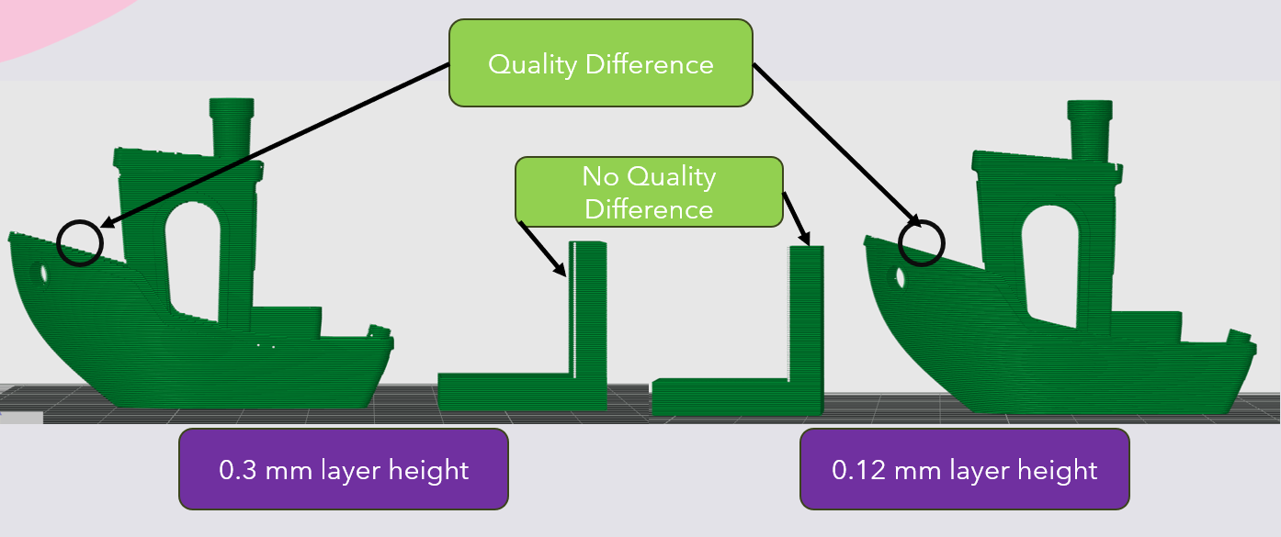
When there are no strict requirements for the print quality or tolerances, use the larger layer heights to save you time and prototype faster. If tolerances and curvature are essential, it is recommended to use 0.20 mm Standard. For cosmetic prints, you may require higher resolutions.
Under Quality in the sidebar
- Layer Height: defines the default layer height the printer will print it. Note how this is different to the nozzle diameter ( it controls the layer height, whereas the nozzle diameter controls the thickness of the line extruded).
Under Strength in the sidebar
- Wall Loops controls the numbers of solid walls dictates how many walls are around each vertical face. The thickness of each wall ~ nozzle diameter
- Top/bottom shells settings controls the solid layers on the top and bottom of parts, including the number, thickness and pattern
- Infill
  - Sparse Infill Density defines the volume of space that contains structural infill. BambuStudio defaults to 15% but 5-10% is sufficient for most non-structural prints, saving you time. Doubling infill density does not double your parts strength. The image below provides results, which will not always be representative but should give you an idea of the effect.
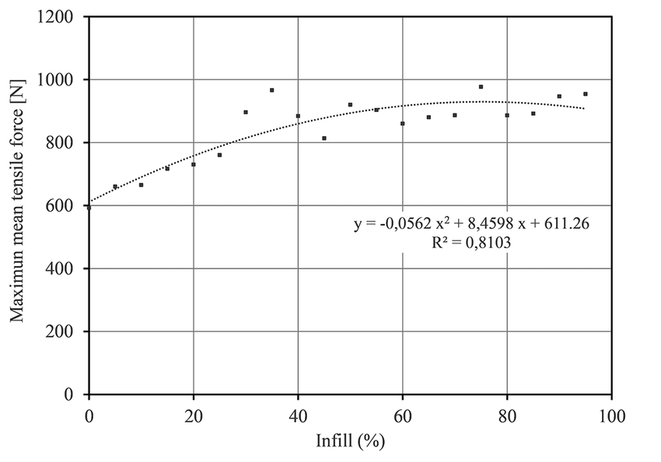
Investigating the influence of infill percentage on the mechanical properties of fused deposition modelled ABS parts
  - Spare Infill Pattern: controls the pattern of infill. It is useful to research into which infill patterns are useful and for which application Cura Guide to the Best Infill Patterns . Gyroid infill is a great default choice and Lightning is great for non-structural rapid prototyping.
Speed in the sidebar will be ignored for the purposes of this document.
Under Support in the sidebar
- More information about supports can be found in What are supports in 3D printing? But the idea is that when the material is required in a otherwise unsupported region, material will sag or in worst case the print will fail altogether. This can be overcome with supports
- Type: the 2 most common types are Tree/organic and grid/normal supports. Tree supports are preferred in most applications unless you have a large flat area, however they take longer to print.
- Threshold Angle defines at what angle relative to the vertical axis, at which the slicer should include supports on a given surface.
- On build plate defines whether support should only build from the plate, or if support can originate from directly on the model.
Under Other in the sidebar
- Skirt inserts (typically) a single loop around the print area.
- Brim is useful for tall slender parts, as they offer better adhesion to the bed than the part on its on. It can also aid with parts with a large contact area on the bed from warping.

Printing
- Once you have applied the appropriate settings, press Slice Plate on the top right of the interface
- (Once sliced, you can return to the previous Setup interface by selecting Prepare on the top left)
- Under color scheme, select Line Type
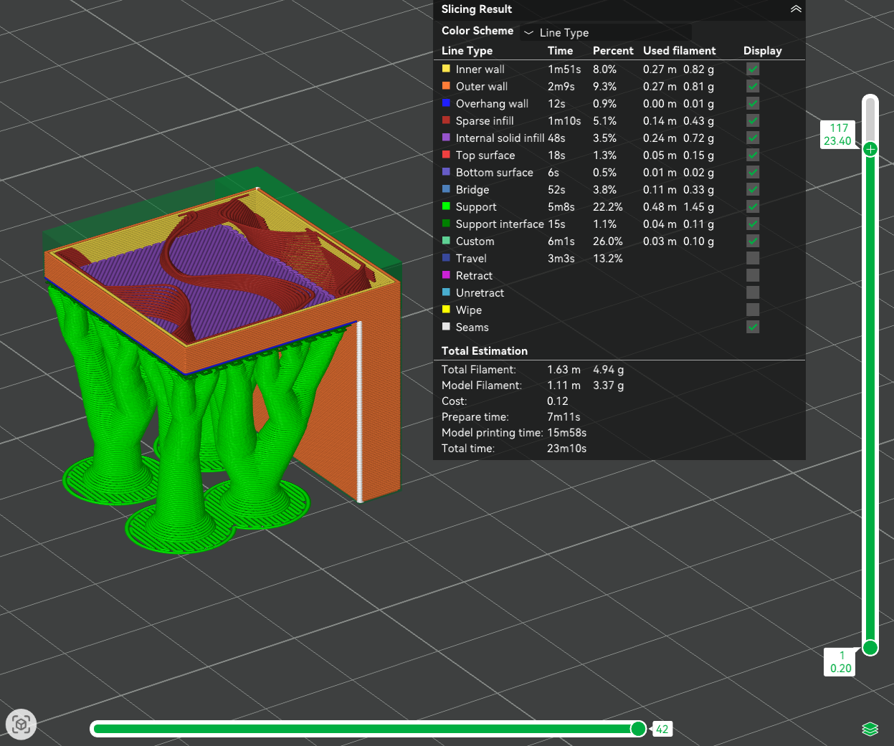
- You can see details including, different features, print times and you can adjust the sliders on the right and bottom to visualise stages in printing.
- If you are ready to print, it is most likely that you will export the file via an SD card (though other methods do exist)
  - Press the drop down for Print Plate
  - Select Export Plate Sliced File
  - Press Export Plate Sliced File
  - Choose an appropriate location (SD card) and name the file so its easy to differentiate and provide a short code so someone can inform you if your print fails
- You will then insert the SD card into the printer. Ensure the printer is clear – no filament on the bed, etc – and the print your file. And watch the first 3 layers print before leaving the room

Removing & Post Processing
- Once your print is complete, it is best to let the print bed cool – parts tend to lose adhesion to the bed and come off.
  - (bed temperature can be found on the printer UI)
- Once cooled, pull and slide the bed towards you.
- Flex/bend the bed: some parts may come off
- If some parts are still on the bed, use a bed scraper or tweezers, to separate parts from the bed ensuring you do not scratch the bed
- Ensure you remove the primer line on the print bed!
- Put the print bed back, in the correct orientation and ensuring its flat on the print surface
- Removing supports
  - Some support can be removed manually.
  - If manual support is not possible, use the available (and provided for the purpose) tool to remove support. For example, flush cutters can be used if provided.

Materials
In depth information can be found here Guide to 3D Printing Materials: Types, Applications, and Properties however the most common filaments you will use
- Polylactic Acid (PLA): Most commonly available filament. Strong but very Brittle
- Polyethylene Terephthalate Glycol (PETG): Has a tad more ductility than PLA
- Thermoplastic Polyurethane (TPU): Very flexible filament. Its flexibility can be further optimised by adjusting print settings.
- Acrylonitrile Butadiene Styrene (ABS): Tougher than the previous materials. It is best to print in an enclosure, to minimise warping and avoid toxic fumes.
Different filaments may have custom requirements, such as an enclosure or an hardened nozzle.
Carbon Fibre hybrid filaments are not magically as strong as real carbon fibre. Please note that abrasion of carbon fibre infused filament may pose health hazards.

Ensuring Prints Succeed

- Bambu Labs printers are one of the lowest maintenance printers on the market, however they can easily be damaged if not used responsibly or taken care off – and that holds for any printer.

In the sliced file:
- Has the correct filament and nozzle diameter been selected?
- Check for any warnings or errors.
- Check for any unsupported overhangs which the printer may fail to print. Add support if needed
- Check for any thin tall regions or features which may lose adhesion to the bed. Add a brim if needed
In the printer:
- Ensure the bed is clean – there is no residual print on the bed and the primer line (a line of filament produced at the start of any print to clean the nozzle) is removed.
- Make sure the bed is placed properly and level.
- Wait for the first 3 layers to print before leaving. 90% of prints fail in the first 3 layers and identifying it early will save you time, material and breaking a printer.

Design for Manufacture in 3D Printing

Design for Manufacture becomes an essential part of your career as an engineer but most people do not realise its importance until after graduation. Thinking about it can make projects save money and more feasible and this extends to:
- 3D printing
- University projects
- Industry: High volume production CNC/ Injection moulding /etc
If there is one thing to take away from how to design for manufacture, its speak to manufacturers and ask why a part is complex to manufacture and how it can be made easier to manufacture

It is a really useful skill to mention on your CV – if you actually understand it. But it is different for each manufacturing method and we will briefly focus on 3D printing. Even though you think that 3D printing is rapid prototyping, designing for 3D printing saves time and resources.

There are plenty of online guides for DFM in 3D printing, not limited to:
- Ultimate Design Guide for 3D Printing | by Wikifactory - Engineer the Future | Medium
- Design for FDM 3D Printing: The Ultimate Guide
- How to design parts for FDM 3D printing
- It is worth researching how to design features for 3D printing - snap fits, threads, etc – when you intend to use them.

- Clearances: It is recommended to research what clearances you should provide between parts for 3D printing as the accuracy is less than other methods and thermal expansion becomes an effect. If you need to test a tolerance/fit where you are unsure about the exact fit – print a test part. For example, if you want to test that a shaft fits in a 100 mm long bore, but you are unsure how much the print will shrink. Print a test piece to verify the fit and make adjustments
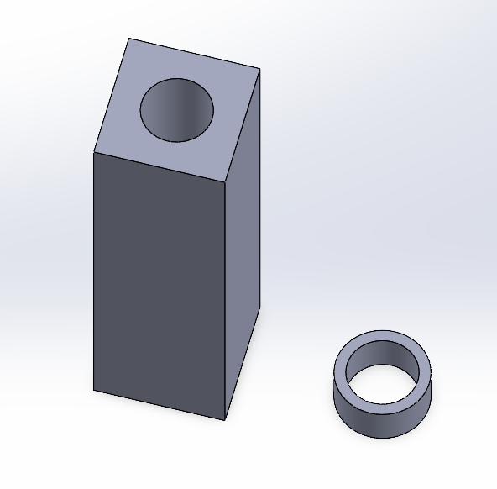
- Think about your Printing orientation from the start
  - Design features that reduce the need for support
  - Consider part strength due to layer lines
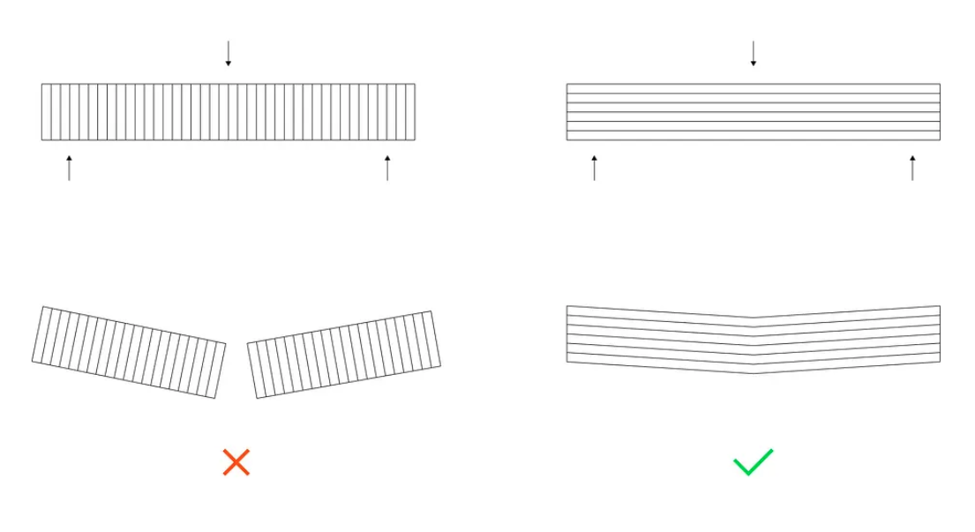
Source: Ultimate Design Guide for 3D Printing
  - For example the part below is a housing (150x100mm) for a component:
    - In its application it is used with the hidden face (right rear), on the ground, however it is printed in the displayed orientation.
    - Slots are put in place to reduce the material & time (~3 hours saved)
    - All overhangs are 30° so no support material is required
    - A consequence of the orientation is that many holes are printed in the orientation that results in poor quality – fortunately the concentricity of these holes is not essential to the part as they are Clearance holes.
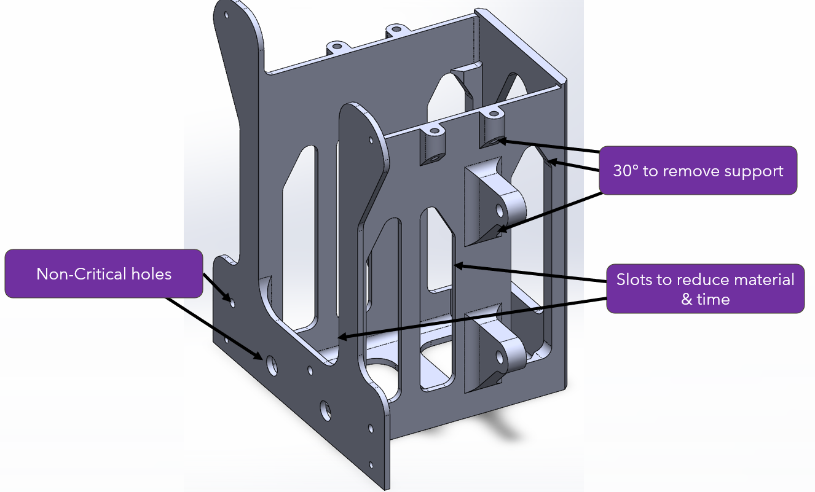
  - Try to minimise the need for support – it adds material, time and leaves a poor surface finish. But sometimes it will be necessary
  - Bridging allows a 90° overhang to be produced over short lengths.
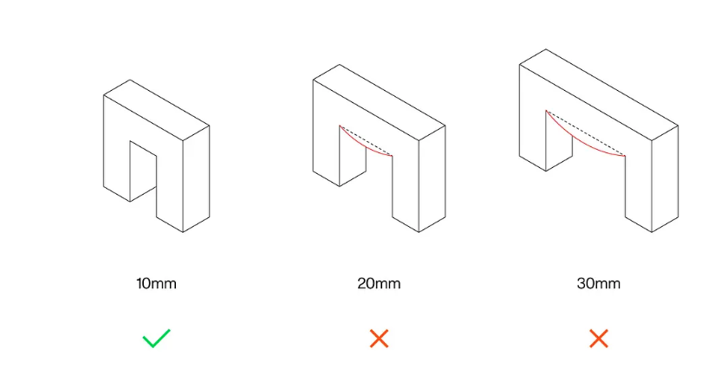
Source: Ultimate Design Guide for 3D Printing
- Wall thickness: When printing shelled out parts, the wall thickness can be kept small. 2 mm wall thickness is plenty for non-structural parts and 4 mm is plenty (depending on the application) for structural parts. However, ensure your wall thickness is not too small (at least 0.8 mm is a good starting point).
- Minimum feature size should be at least 2 mm wide (this would depend on your nozzle diameter, but assuming 0.4 mm). Pins should be at minimum 3 mm in diameter.
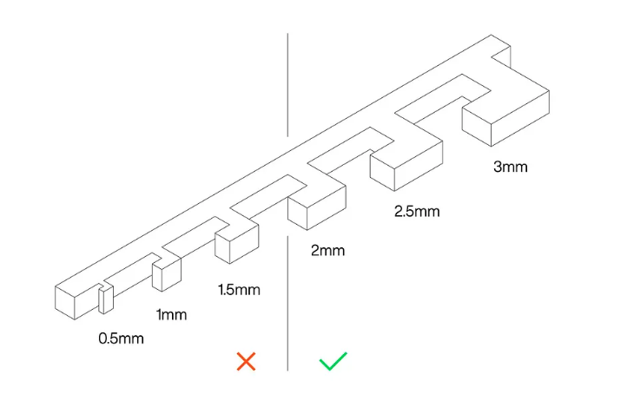
Source: Ultimate Design Guide for 3D Printing

- Holes:
  - Print holes with their axes vertical as opposed to horizontal, Vertical holes will be more concentric.
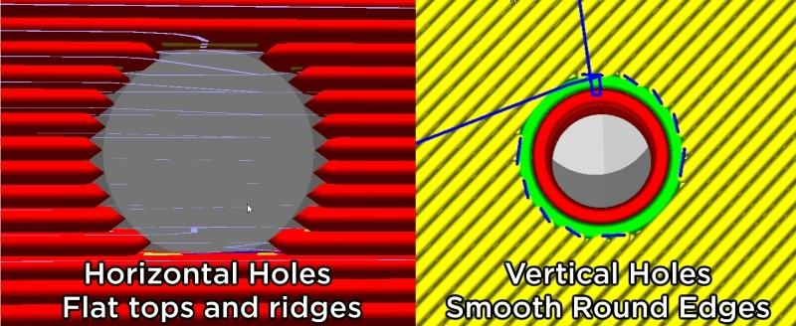
Source
  - Horizontal holes printed are often undersized and you will be required to compensate for this
- Use rounded edges, so the extruder does not have to make a sharp turn when printing
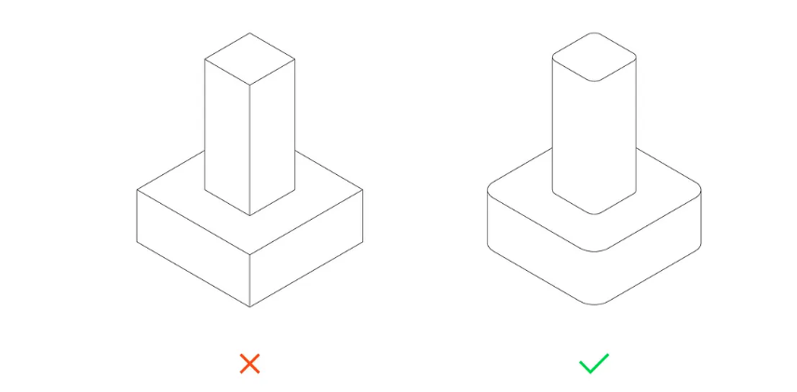
- Do not filet the bottom edges (face in contact with the bed) as this promotes warping. Chamfers are ideal as it prevents elephant's foot. Source
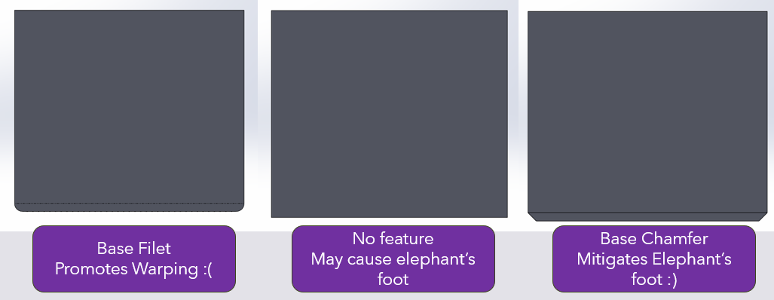
Source: Ultimate Design Guide for 3D Printing
- Rib features will add strength to your walls – but increase the number of perimeter and print time.
- It may be easier to split a part into multiple parts for printing and then assemble them together (discussed in Advanced 3D Printing Settings)
- It is a lot easier to design modular assemblies. Print parts separately and bolt them together, rather than having to reprint a large part all over again because one tolerance was wrong.

Advanced 3D Printing & Settings

- Print Orientation for strength
  - Which is the best orientation to print in?
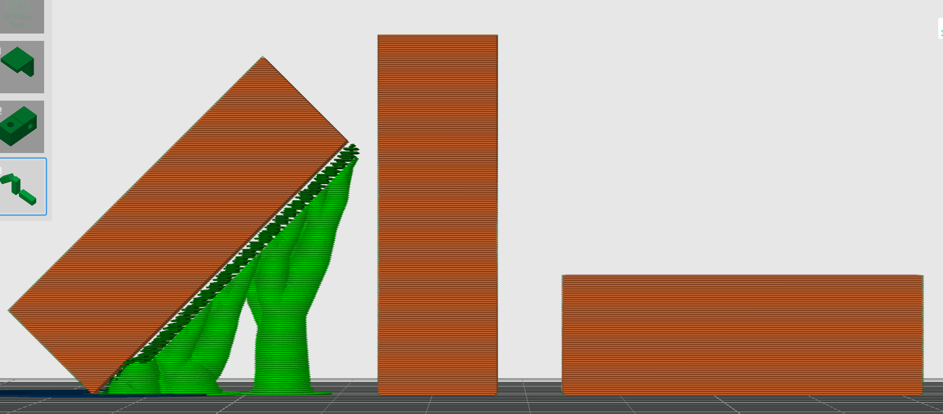
  - The answer is – it depends on context! Since the layer lines dictate the strength of a part. FDM parts are anisotropic and much more likely to fail across layer lines

Source: Ultimate Design Guide for 3D Printing

  - Right object will be good against bending across its length
  - Middle objection will be good in compression across its length, but terrible in tension
  - The left object is a compromise between the two previous options but is more of a hassle to print

Note: Subsequent features will be briefly discussed and will be left to the read to research into. Many of them require trial and error it is best to test the features independently before committing to a major print.
- Fasteners: There are many ways to implement fastener into 3D prints
  - Simplest: Nut and bolts
  - More robust: Threaded brass inserts – in which you insert a brass insert into a hole (e.g. an M3 brass insert embeds into a 4.2 mm printed hole)
  - Self-tapping fasteners
- Springs: Printables
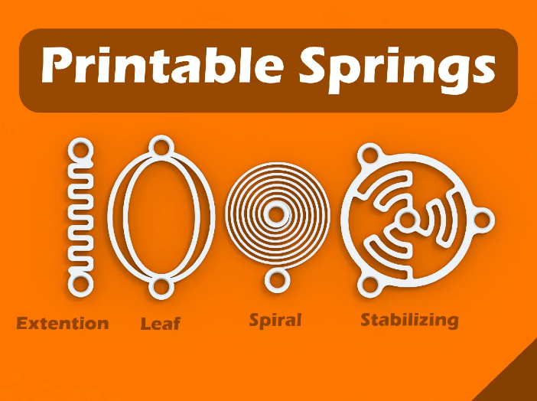
- Snap Fits: https://formlabs.com/blog/designing-3d-printed-snap-fit-enclosures/ . Consider layer orientation with printing snap fits!
- Living hinges: https://www.hubs.com/knowledge-base/how-design-living-hinges-3d-printing/
- Print in place: It is possible to prints multi bodies that function together without assembly https://www.printables.com/model/49060-hinge-print-in-place-optimized-for-3d-printing/files
- Variable Layer Height: Useful when dealing with large model curvature in specific regions
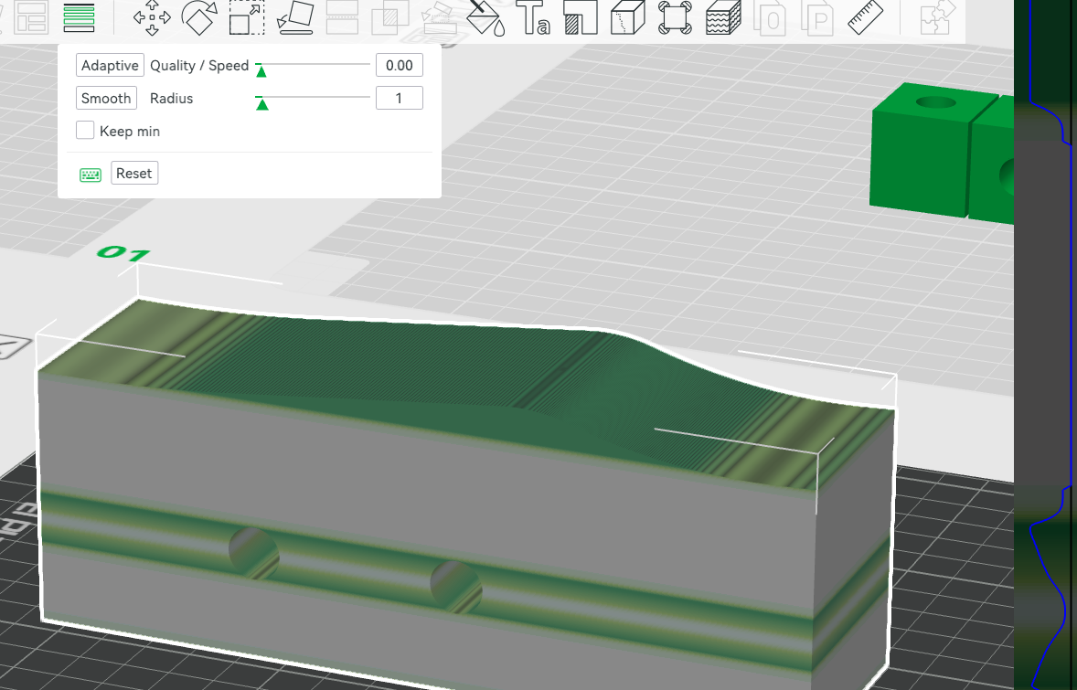
- Text: Add embossed or Debossed Text onto a model. It is useful to embed the version of parts. Ensure the text is large enough to be visible
- Split Parts
  - Useful when it is easier to split parts and then assemble then
  - Printing curved surfaces (cylinders/Spheres) on the plate will result in a flat bottom on the part. You can split a sphere up – printing it on its flat face and then join them together after, but consider tolerances.
  - Connectors: Useful locators to determine where parts should mount. Dowels are recommended since you can re-try printing dowels pins quickly rather that reprinting entire parts. Non circular dowels are ideal as they are easier to print with its length on the build plate – so that the layer lines are in a favourable orientation.
  - Dovetail mode provides a slot to align the split parts into.
- Paint on supports: Enable you to control where support should and should not be on the model
- Fuzzy skin: Gives a rough finish on parts – useful for grip. There are (few) software which enable you to implement custom textures https://bumpmesh.com/
- Ironing: Useful if the top surface needs a very good finish, but adds significant printing time
- Rafts: Useful to reduce warping and can improve adhesion to the bed.
- Print Sequence: Change to print part by part instead of layer by layer, provided it does not crash into other parts

Printing Failures?

There are a number of failures that can occur during printing, and you are encouraged to research them, why they occur and how to resolve them. Though in university, it is best to stop the print and inform the relevant member of stuff if something is wrong. Failures include:
- Poor bed adhesion. Causes include but not limited to:
  - Incorrect bed temperature
  - Unclean bed
  - Poor z-offset or bed levelling
- Stringing of filament in prints
  - Filament is wet
  - Incorrect nozzle temperature
- Clogged nozzle
- Over/Under extrusion
- The blob of death

